IDEATION PHASE
DEFINE THE PROBLEM STATEMENT

Date | JUNE 2025
Team ID | LTVIP2025TMID50933
Project Name | ToyCraft tales: tableau's vision into toy manufacturer data
Maximum Marks | 2 Marks

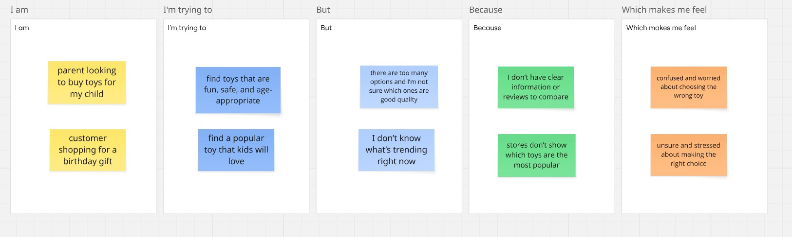

Problem Statement (PS) | I am (Customer) | I’m trying to | But | Because | Which makes me feel
PS-1 | parent looking to buy toys for my  child | find toys that are fun, safe, and age-  appropriate | I’m not sure which ones are good  quality | I don’t have clear information or reviews  to compare | confused and  worried
PS-2 | customer shopping for a birthday gift | find a popular toy that kids will love | I don’t know what’s trending  right now | stores don’t show which toys are the  most popular | unsure and stressed

